**A7 - Sensors**

**Esraa Abdelmoein**

**2025-10-20**

**Here is my GitHub URL: https://github.com/EsraaAbdelmoein/Mobile-Application-Android/tree/main/Assignment07_Sensors/M07_InteractiveGalaxy**

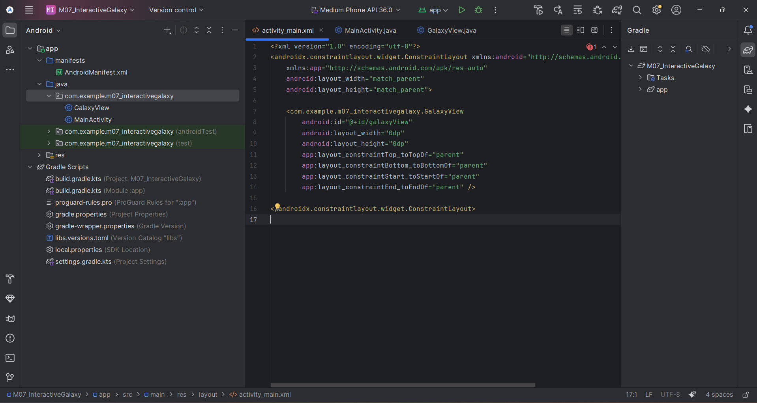

**Gravity Sensor Setup (MainActivity.java)**  
This code registers the gravity sensor and updates the object's X and Y positions in real time. The values are used to simulate tilt movement inside the game

**Touch Input Handling (GalaxyView.java)**  
This part of the code detects when the user touches or drags on the screeN.The paddle moves or new balls are created according to the touch actions

**Drawing and Game Updates (GalaxyView.java)**  
This section draws the paddle, balls, and score on the canvas. It updates the positions continuously to create the animation

**Gravity Sensor Handling (GalaxyView.java)**  
This part receives gravity sensor data and uses it to control the paddle movement in the game

**Scoring and Winning Logic (GalaxyView.java)**  
This part of the code increases the score each time the paddle hits a ball and displays a “You Win”message when the player reaches the target score

Logcat output confirming that the app runs successfully without any errors